**BIRD WATCHING AT KAREN!**

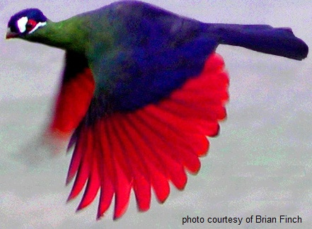

**Date: Tuesday 28 February 2017**

**Venue: Karen Country Club**

**Time: 7.00 a.m.**

**Requirements: Binoculars and bird book**

**John Dawson has kindly agreed to lead this walk**